Date: 19.07.2024
PRODUCT DATA SHEET
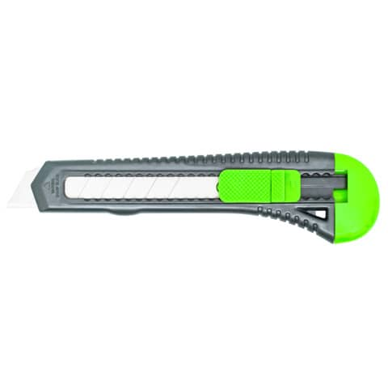 | Item number:
 | E-84003 IA / KF10632
 | Brand:
 | Q-Connect
 | Description:
 | Q-Connect Cutter blade 18mm, plastic housing, grey/green, KF10632

PRODUCT INFORMATION
Colour: | Blade material:
grey/green | carbon steel
Body material: | Product Weight
plastic | 0,028 kg
Customs tariff number: | Cardboard weight
82119300 | 0,009 kg
Product Origin | Blister weight
China | 0,003 kg

LOGISTIC INFORMATION
Single packaging | Single Weight | Single Measures | Unit
Blister | 0,04 kg | 21,9 x 7 x 1,5 cm | 1
Inner packaging | Inner Weight | Inner Measures | Units by box
Carton box | 0,915 kg | 22,5 x 18,5 x 7,5cm | 20
Master packaging | Master Weight | Master Measures | Units by box
Carton box | 9,6 kg | 38 x 25 x 40 cm | 200
EAN Single: | 5705831106321
EAN Inner: | 5706002147518
EAN Master: | 5706003147517

MARKETING TEXT
Cutter with plastic rail guide for light cutting work. With removable end cap for breaking off used blades. Supplied with 1 blade. Blade shape: 18 mm wide.

