Date: 10.12.2024
PRODUCT DATA SHEET
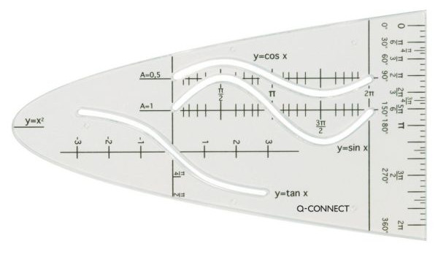 | Item number:
 | KF00597 / E-10213 IA
 | Brand Name:
 | Q-Connect
 | Description:
 | Q-Connect Parabo., unit parsable (y = x²), unbreak., transp. PS; ink edges, With 3 curves, KF00597

PRODUCT INFORMATION
Colour: | Material:
Clear | Plastic
Product Origin | Product Weight
China | Xx kg
Customs tariff number | Pacakging weight
90178010 | Xx kg

LOGISTIC INFORMATION
Single packaging | Single Weight | Single Measures | Unit
Poly bag with Header | 0,0110 kg | 15,5 x 7,5 x 0,2 cm | 1
Inner packaging | Inner Weight | Inner Measures | Units by box
Carton box | 0,48 kg | 32,5 x 17,5 x 35 cm | 40
Master packaging | Master Weight | Master Measures | Units by box
Carton box | 7 kg | 32,5 x 17,5 x 35 cm | 560
EAN Single: | 5705831005976
EAN Inner: | 5706002005979
EAN Master: | 5706003005978

MARKETING TEXT
Q-Connect Parabola - transparent
With sine, cosine and tangent curves.
Perfect for school, office and at home.

