Date: 12.12.2024
PRODUCT DATA SHEET
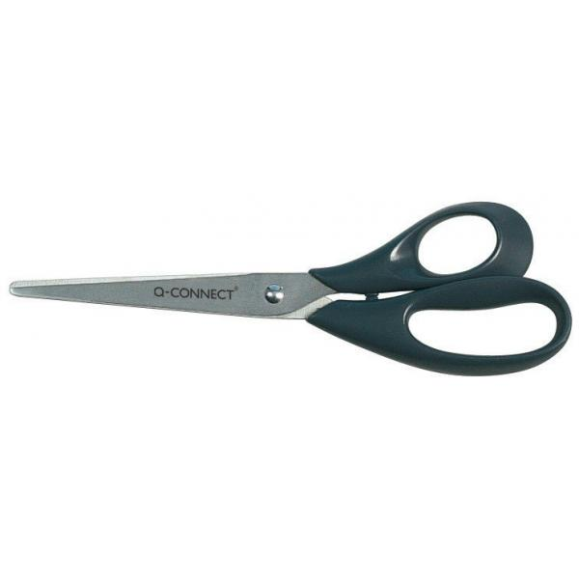 | Item number:
 | KF01227
 | Brand Name:
 | Q-Connect scissors 210mm
 | Description:
 | All purpose scissors with black handle

PRODUCT INFORMATION
Colour: | Blade material:
black | Stainless steel
Full length: | Handle material:
approx. 21cm / 8” | PP
Shape of tip: | Product Weight
pointed | 0,052 kg
Product Origin | Customs tariff number:
China | 82130000

LOGISTIC INFORMATION
Single packaging | Single Weight | Single Measures | Unit
Rivet card | 0,063 kg | 23 x 9 x 1,2 cm | 1
Inner packaging | Inner Weight | Inner Measures | Units by box
Carton box | 0,98 kg | 12,5 x 23,x 9,5 cm | 15
Master packaging | Master Weight | Master Measures | Units by box
Carton box | 10,17 kg | 25,5 x 49,5 x 27,5 cm | 150
EAN Single: | 5705831012271
EAN Inner: | 5706002012274
EAN Master: | 5706003012273

MARKETING TEXT
The Q-CONNECT® All-Purpose scissors are ergonomic with an excellent cutting quality. The rounded plastic handles make cutting papers and other materials comfortable and easy.

