Date: 10.07.2023
PRODUCT DATA SHEET
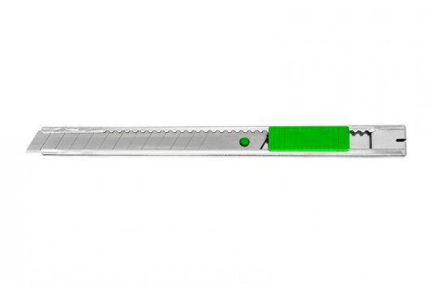 | Item number:
 | E-84037 IA / KF00234
 | Brand:
 | Q-Connect
 | Description:
 | Q-Connect Cutter blade 9mm, metal blade guiding, metal handle, grey/green, KF00234

PRODUCT INFORMATION
Colour: | Blade material:
grey/green | carbon steel
material: | Product Weight
Metal, plastic | 0,013 kg
Customs tariff number: | Cardboard weight
82119300 | 0,006 kg
Product Origin | Blister weight
China | 0,003 kg

LOGISTIC INFORMATION
Single packaging | Single Weight | Single Measures | Unit
Blister | 0,022 kg | 18,9 x 6,5 x 1 cm | 1
Inner packaging | Inner Weight | Inner Measures | Units by box
Carton box | 0,5 kg | 19,5 x 12,5 x 6 cm | 20
Master packaging | Master Weight | Master Measures | Units by box
Carton box | 5,35 kg | 27 x 21 x 33 cm | 200
EAN Single: | 5705831002340
EAN Inner: | 5706002147549
EAN Master: | 5706003147548

MARKETING TEXT
Q-Connect Light Duty Cutting Knife with metal blade guiding, features a pocket clip at the back. (Refill blades are available see KF14757)
Technical information: 9mm blade, 13 blade ends, metal blade guiding, pocket clip, Made in China

